Munster Technological University

Title
Student Name: Parag Soni
Student No: R00208553

Time Series & Factor Analysis

Master of Science in Data Science & Analytics, Department of Mathematics, 20th May 2022

Student Examination Declaration

I, Parag Soni, hereby declare that the work submitted is my own. I declare that I have not obtained unfair assistance via use of the internet or a third party in the completion of this examination.

I acknowledge that the Academic Department reserves the right to request me to present for oral examination as part of the assessment regime for this module.

I confirm that I have read and understood the policy and procedures concerning academic honesty, plagiarism and infringements.

I understand that where breaches of this declaration are detected, these will be reviewed under CIT’s policy and procedures concerning academic honesty, plagiarism and infringements, as well as any other Institute regulations and policies which may apply to the case. I also understand that any breach of academic honesty is a serious issue and may incur penalties.

Principal Component Analysis & Factor Analysis

In this report we are going to perform Principal Component Analysis and Factor Analysis on a dataset named “FA_STAT9005_Project.sav”. This dataset contains information of Cars that were selected at random from among 93 American passenger car models that were listed in both the Consumer Reports issue and the PACE Buying Guide magazines. The dataset has 16 features/Variables.

Variable Name | Description | Type
Origin | Manufacturing company origin. 1=”non-USA” or 2=”USA” | Factor
Price | Price (in $1,000) | Numerical
Type | Level: 1="Small" 2="Sporty" 3="Compact" 4="Midsize" 5="Large" 6="Van" | Factor
Engine | Size Engine size (litres). | Numerical
RPM | RPM (revs per minute at maximum horsepower) | Numerical
Fuel.Tank.Capactity | Fuel tank capacity (US gallons) | Numerical
MPG.city | City MPG (miles per US gallon by EPA rating) Weight Weight (pounds) | Numerical
Weight | Weight (pounds) | Numerical
Cylinders | Type of cylinder 4 stroke 6 stroke | Character
Horsepower | Powe of car | Numerical
Passengers | Number of passenger car can fit | Numerical
Length | Length of car | Numerical
AirBags | Airbags present or not if yes how many | Character
Manufacturer | Car manufacturer | Character
Model | Car model | Character
InsClass | Class of car Low/medium | Factor
Table 1

Not all the variables are relevant as per this report is concerned. We will be working mostly on Initial 8 features from table 1.
This report is divided in 3 parts.
Preliminary analysis
In this section we are going to look into the “R” command that we used in order to prepare data for data reduction analysis.

Correlation-Matrix
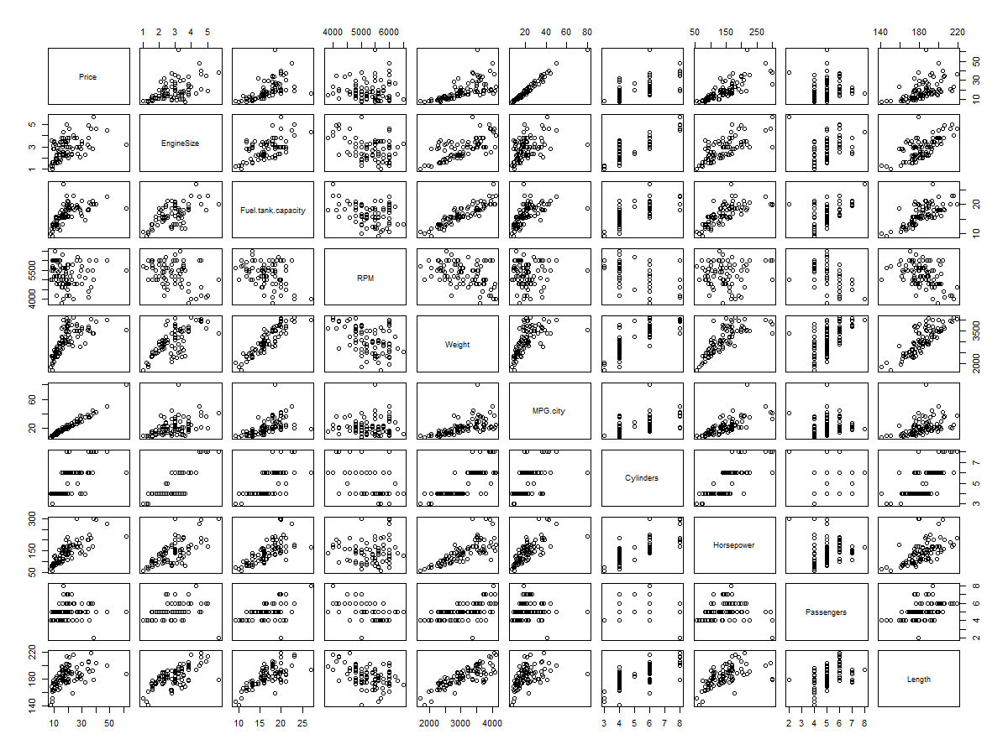
Above correlation matrix was generated by applying pairs() function on the dataset. It gives information on how variables are co related to each other and what type of relationship do they possess for example positive linear, negative linear or no relationship at all.
Corrplot:
Same correlation between variables can be found out using “corrplot” package too. Above plot was generated using same library and it gives out correlation coefficient. Positive correlation coefficient mean positive relationship, negative correlation coefficient mean negative relationship else no relationship.

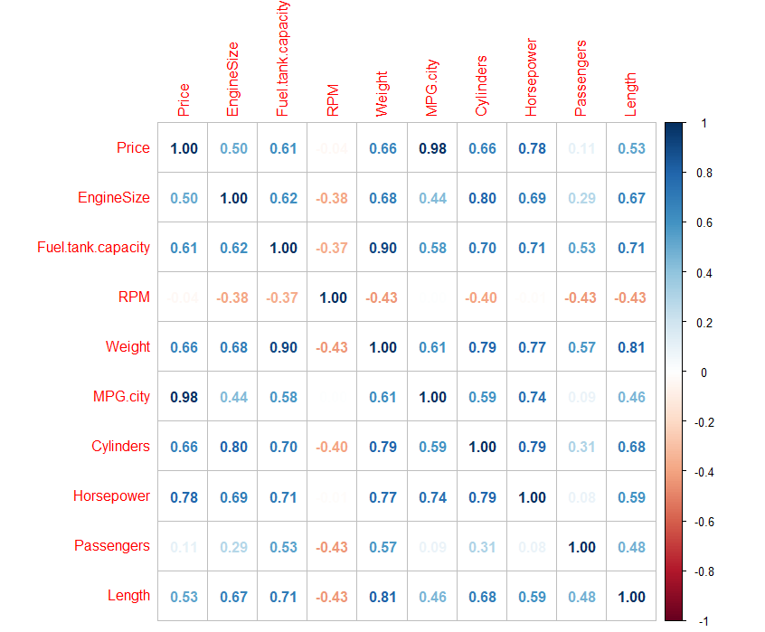
We can easily identify how variables are related to each other with the help of above two plots.
Plots of 3 pairs of variables:
- Horsepower VS Price
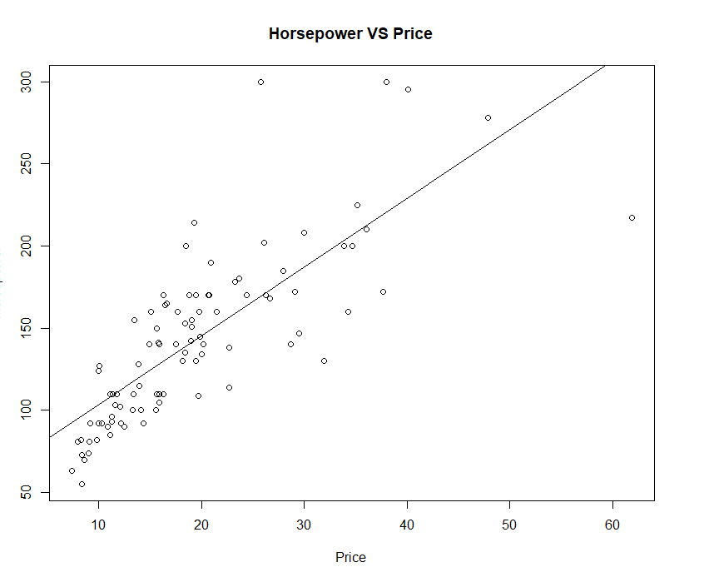
- Engine size VS RPM
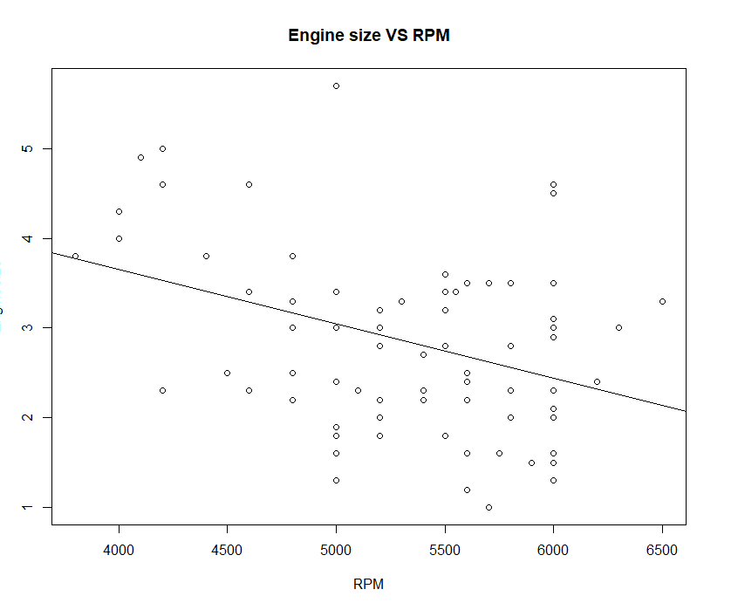
- Fuel tank capacity VS weight
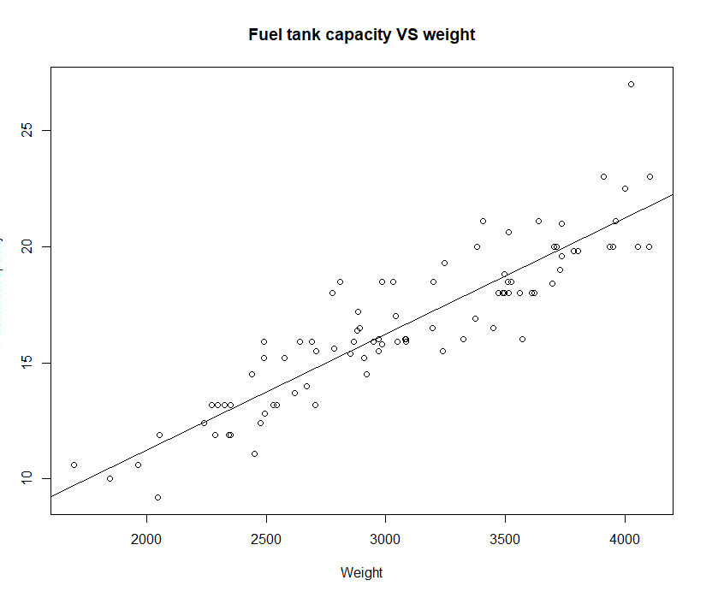
From the above pairs we see except pair (Engine size and RPM) other 2 pairs show positive linear correlation meaning if one increases other increases as well. while the one has negative linear correlation

3D plots to represent the correlation between:
- MPG.city on Cylinders and EngineSize 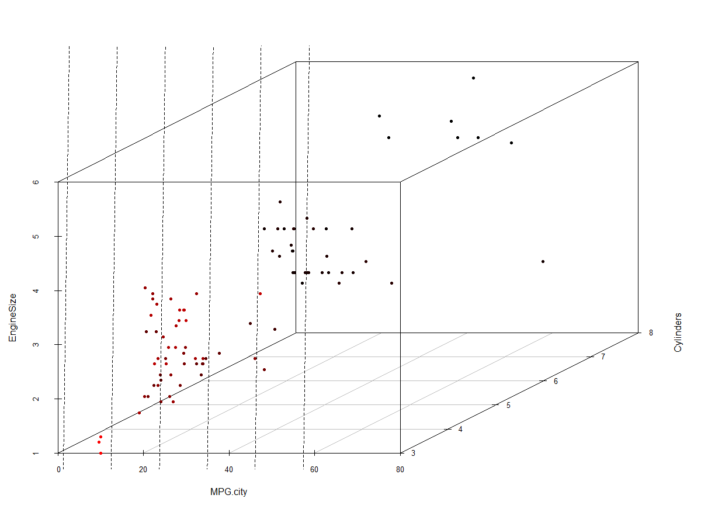
- Horsepower on Cylinders and EngineSize

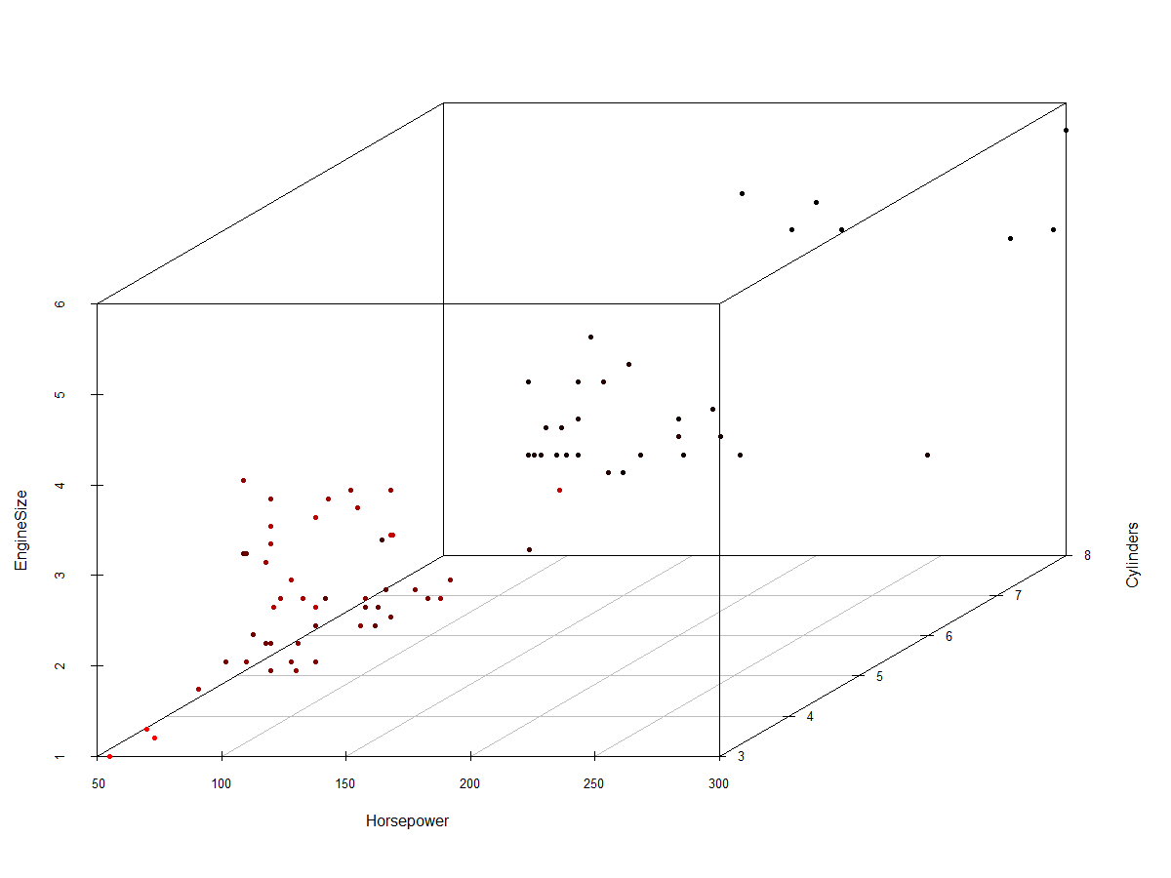

Principal Components

Principal Component Analysis is a dimensionality-reduction mechanism. It is used to reduce dimensionality of large datasets by transforming large set of variables into small set of variables. This small set of variables are transformed in such a way that they still represent most of the information from large set. To summarise PCA is used to reduce the number of variables while preserving as much information as possible.
In order to perform PCA on any data we need to perform Bartlett’s Test of Sphericity first.
Bartlett’s Test of Sphericity compares an observed correlation matrix to the identity matrix. Essentially it checks to see if there is a certain redundancy between the variables that we can summarize with a few number of factors.
The null hypothesis of the test is that the variables are orthogonal, i.e. not correlated. The alternative hypothesis is that the variables are not orthogonal, i.e. they are correlated enough to where the correlation matrix diverges significantly from the identity matrix.
This test is often performed before we use a data reduction technique such as principal component analysis or factor analysis to verify that a data reduction technique can actually compress the data in a meaningful way.[1]
Bartlett test for our dataset gives output as:
$chisq
[1] 1101.148
$p.value
[1] 2.860564e-201
$df
[1] 45

The Chi-Square test statistic is 1101.148and the corresponding p-value is 2.860564e-201, which is smaller than our significance level (0.05). Thus, this data is likely to be suitable for PCA or factor analysis, meaning the variables in our dataset are fairly correlated so a data reduction technique like PCA can be applied.
Now computing PCA
PCA works best with numerical data, so we exclude the categorical variables from our dataset if present. There are various R functions that we can use to evaluate PCA.
I have used prcomp() function where we pass our dataset, assigning output to cars_pca. Other arguments will be, center and scale, to be TRUE.
When we print cars_pca we get below covariance matrix output:

From the above table we can identify variation of variables in all the principal components. For example RPM for PC1 is -0.15 and for PC2 is 0.54. It indicated that RPM is of more importance to PC2 than PC1.
if positive then : the two variables increase or decrease together (correlated)
if negative then : One increases when the other decreases (Inversely correlated)
And the summary looks like

 | PC1 | PC2 | PC3 | PC4 | PC5 | PC6 | PC7 | PC8 | PC9 | PC10
Standard deviation | 2.4634 | 1.3176 | 0.86332 | 0.72476 | 0.55749 | 0.54204 | 0.42045 | 0.29937 | 0.20368 | 0.11207
Proportion of Variance | 0.6068 | 0.1736 | 0.07453 | 0.05253 | 0.03108 | 0.02938 | 0.01768 | 0.00896 | 0.00415 | 0.00126
Cumulative Proportion | 0.6068 | 0.7804 | 0.85497 | 0.90749 | 0.93857 | 0.96796 | 0.98563 | 0.9946 | 0.99874 | 1

We obtained 10 principal components, which is names as PC1-PC10. Each of these explains a percentage of the total variation in the dataset. That is to say: PC1 explains 60% of the total variance, which means that nearly two-thirds of the information in the dataset (9 variables) can be encapsulated by just that one Principal Component. PC2 explains 17% of the variance and so on. So, by knowing the position of a sample in relation to just PC1 and PC2, we can get a very accurate view on where it stands in relation to other samples, as just PC1 and PC2 can explain 78% of the variance.
The cumulative proportion in the above table is nothing but the sum of adjacent PCA, adding to 1 at last.
PC Scores:
 |  | PC1 | PC2
Acura | Integra | -1.50635 | 1.012275
Acura | Legend | 2.385111 | 1.477691
Audi | 90 | 1.133964 | 1.188245
Audi | 100 | 2.725934 | 1.166082
BMW | 535i | 1.732695 | 1.943249
Buick | Century | -0.4654 | -1.04905
Buick | LeSabre | 1.913473 | -1.07002
Buick | Roadmaster | 3.776761 | -2.03004
Buick | Riviera | 2.097685 | -0.18961
Cadillac | DeVille | 4.351071 | -0.65867

scores: Scores are linear combinations of the data that are determined by the coefficients for each principal component. To obtain the score for an observation, substitute its values in the linear equation for the principal component.
From the above table we observe top 10 PCA scores. It showcase coordinates of datapoint on PC1 and PC2 scales. Acura Integra coordinates are (-1.5, 1.01), Acura Legend (2.38, 1.477) respectively for PC1 and PC2.
Eigenvalues and Eigenvectors
Eigenvectors, and eigenvalues come in pairs: every eigenvector has a corresponding eigenvalue. Simply put, an eigenvector is a direction, such as "vertical" or "45 degrees", while an eigenvalue is a number telling you how much variance there is in the data in that direction. The eigenvector with the highest eigenvalue is, therefore, the first principal component.
Eigen value is calculated by squaring standard deviation we got in the above table. The Eigen values are:

From the above result we can see that the eigen values are in descending order. PC1 has the highest eigen value then PC2 and so on.
Now that we have calculated the PCA and their eigen values. We will plot scree plot. A scree plot is a graphical tool used in the selection of the number of relevant components or factors to be considered in a principal components analysis or a factor analysis.

Scree plot looks like:
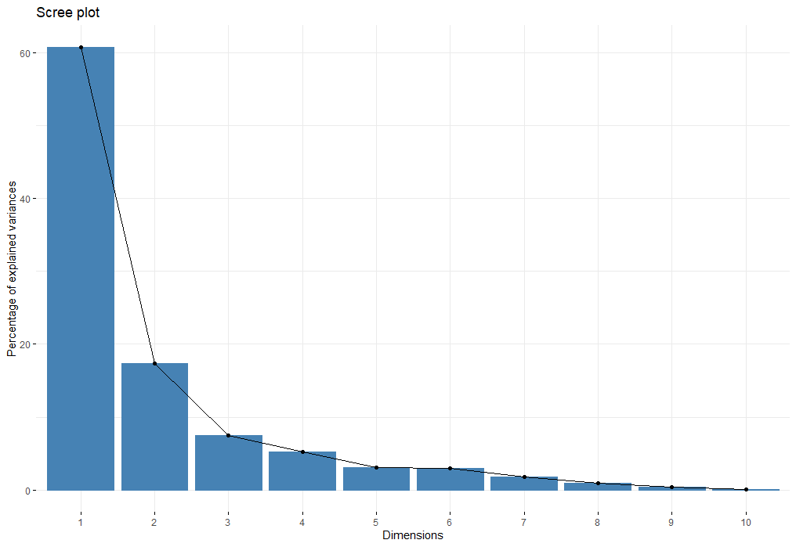
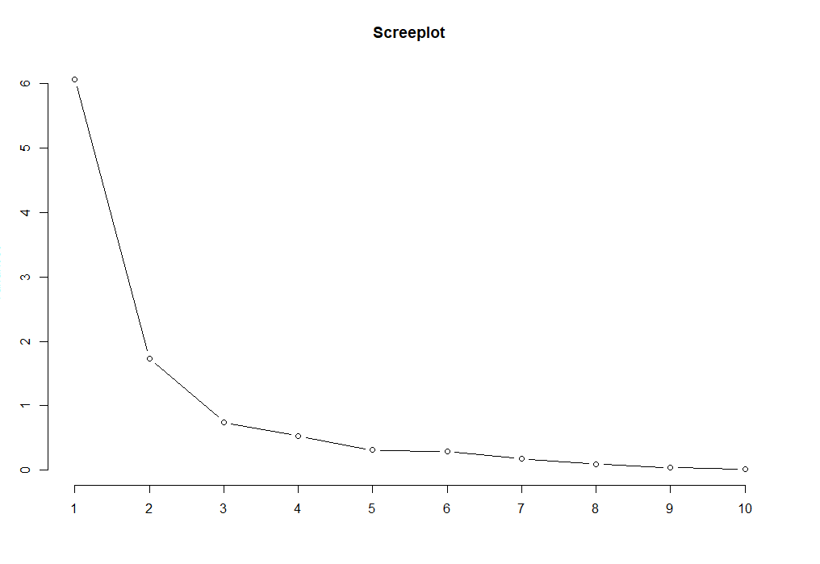

PCA having variance more than 1 are retained rest all are denied. From the above scree plots we can see that PC1 and PC2 have variance greater than 1 rest all are below 1.

Plotting PCA
The axes in the biplot is shown below. This is seen as arrows originating from the center point. Here, you see that the variables except RPM and passenger (, Weight, Cylinder, Fuel tank capacity, Horsepower, length) all contribute to PC1, with higher values in those variables moving the samples to the right on this plot. Similarly RPM, Price MPG city contribute to PC2. This lets us see how the data points relate to the axes, but it's not very informative without knowing which point corresponds to which sample (car).
Thus with the plot below we can identify which cars similar to one another. For example Mercedes Benz-300E, Chevrolet, corvette infinity are similar to each other with same kind of variables effect.

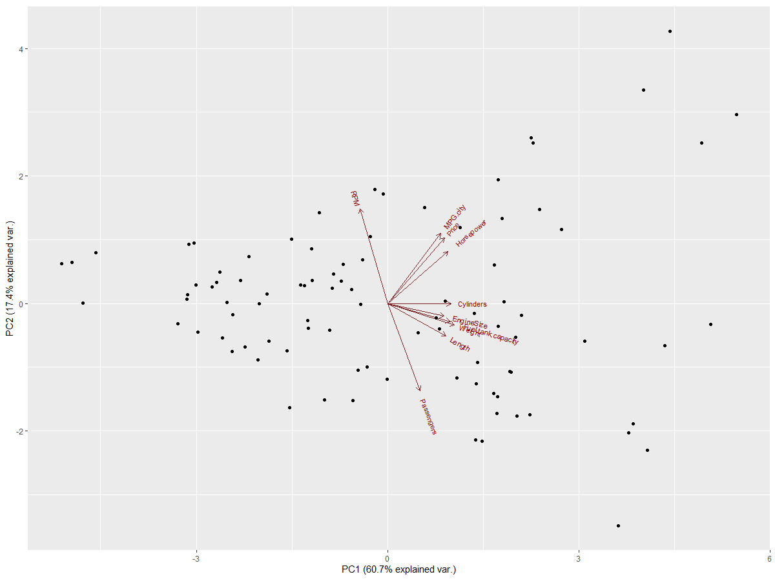
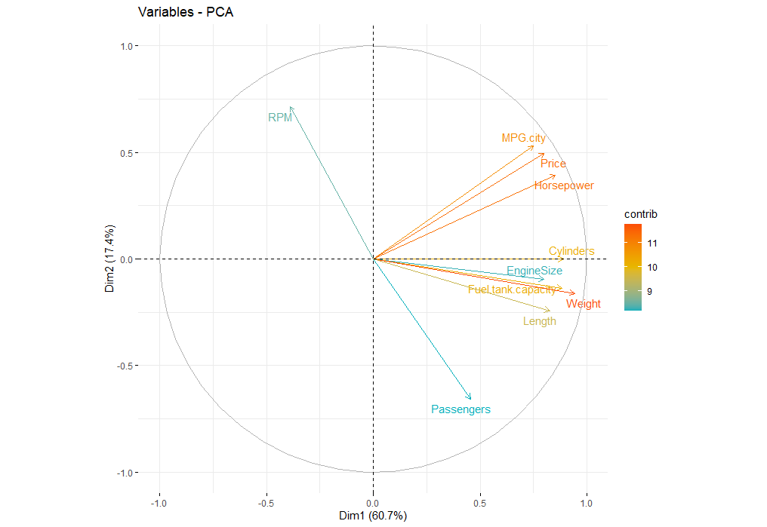
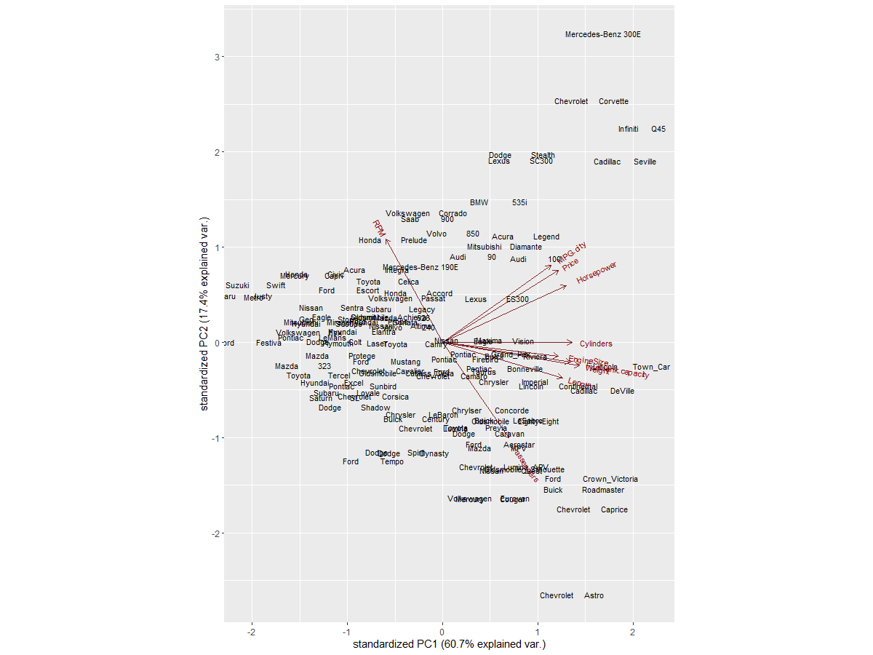
Weights of variables in PC1 and PC2 are described below:
 | PC1 | PC2
Price | 0.324737 | 0.376196
EngineSize | 0.323987 | -0.07177
Fuel.tank.capacity | 0.358016 | -0.10476
RPM | -0.15851 | 0.541424
Weight | 0.383032 | -0.12267
MPG.city | 0.304346 | 0.402868
Cylinders | 0.361604 | -0.00033
Horsepower | 0.346143 | 0.297679
Passengers | 0.184698 | -0.49905
Length | 0.335041 | -0.18492

Factor Analysis
In statistics variables that are not directly observed but are rather inferred from observed variables are referred to as latent variables. Mathematical models that aim to explain observed variables in terms of latent variables are called latent variable models. Such a latent variable model provides the link between the latent variables, which cannot be observed, and the manifest variables which can be observed.

Factor analysis is an application of latent variable models. The purpose of the analysis is to determine how many latent variables are needed to explain the correlations between the manifest variable, to interpret them and, sometimes, to predict the values of the latent variables
The basic idea behind factor analysis is that we investigate a multivariate feature space covered by a set of observable variables and that we describe the variability and correlation among the observed variables in terms of a potentially lower number of unobserved variables denoted as factors.
There are two main branches in factor analysis:
- Confirmatory factor analysis (CFA)
- Exploratory factor analysis (EFA)[2]

In R we perform Factor analysis on our dataset using the “factanal” from the library “psych”.
This function takes 3 argumnets in our code, Dataset, number of factors to be fitted, and rotation.
From the factor analysis diagram we can say that MR1 and MR2 are positively correlated to each other and Mr1 and MR3 are positively correlated.
Factor analysis usually proceeds in two stages. In the first, one set of loadings, Λ, is calculated which yields theoretical variances and covariances that fit the observed ones as closely as possible. These loadings, however, may not provide a reasonable interpretation. Thus, in the second stage, the loadings, Λ, are transformed in an effort to arrive at another set that fit equally well the observed variances and covariances, but are easier to interpret.
The process of transforming a factor pattern is generally referred to as rotation. The varimax method maximizes the variance of the squared loadings for each factor, thus making some of these loadings as large as possible, and the rest as small as possible in absolute value.
Output:
Call:
factanal(x = usa_data, factors = 2, rotation = "varimax")

Uniquenesses:
Price EngineSize Fuel.tank.capacity RPM Weight MPG.city Cylinders
0.021 0.339 0.178 0.718 0.017 0.024 0.215
Horsepower Passengers Length
0.277 0.530 0.419

Loadings:
Factor1 Factor2
Price 0.982 0.122
EngineSize 0.677 0.450
Fuel.tank.capacity 0.473 0.774
RPM -0.134 -0.514
Weight 0.630 0.765
MPG.city 0.984
Cylinders 0.753 0.467
Horsepower 0.793 0.306
Passengers 0.686
Length 0.487 0.586

Factor1 Factor2
SS loadings 4.463 2.799
Proportion Var 0.446 0.280
Cumulative Var 0.446 0.726

Test of the hypothesis that 2 factors are sufficient.
The chi square statistic is 96.99 on 26 degrees of freedom.
The p-value is 4.05e-10
Here the above output is for 2 factors. This is a bit tricky to guess number of factors. PCA is helpful in guessing this.

The first chunk provides the uniqueness’s, which range from 0 to 1. The uniqueness, sometimes referred to as noise, corresponds to the proportion of variability, which cannot be explained by a linear combination of the factors. A high uniqueness for a variable indicates that the factors do not account well for its variance.
The next section is the loadings, which range from −1 to 1. This is the Λ^ in the equation above. The loadings are the contribution of each original variable to the factor. Variables with a high loading are well explained by the factor. Notice there is no entry for certain variables. That is because R does not print loadings less than 0.1. This is meant to help us spot groups of variables. Type help(loadings) in your console for further details.[3]

By squaring the loading we compute the fraction of the variable’s total variance explained by the factor (Teetor 2011). This proportion of the variability is denoted as communality. Another way to calculate the communality is to subtract the uniquenesses from 1. An appropriate factor model results in low values for uniqueness and high values for communality.
The table beneath the loadings shows the proportion of variance explained by each factor. The row Cumulative Var gives the cumulative proportion of variance explained. These numbers range from 0 to 1. The row Proportion Var gives the proportion of variance explained by each factor, and the row SS loadings gives the sum of squared loadings. This is sometimes used to determine the value of a particular factor. A factor is worth keeping if the SS loading is greater than 1 (Kaiser’s rule).[3]
Factor loading is basically the correlation coefficient for the variable and factor. Factor loading shows the variance explained by the variable on that particular factor. In the SEM approach, as a rule of thumb, 0.7 or higher factor loading represents that the factor extracts sufficient variance from that variable.[2]
Thus from the above output Factor 1 extracts sufficient variance from variables Price, EngineSize, MPG.city , Cylinders and Horsepower. It describes about engine capacity and speed of car
And Factor 2 extracts sufficient variance from variables Fuel.tank.capacity, RPM, Weight, Passengers and Length. It describes about efficiency, more passengers and affordability of car.

The last section of the function output shows the results of a hypothesis test. The null hypothesis, H0, is that the number of factors in the model, in our case 2 factors, is sufficient to capture the full dimensionality of the data set.

A biplot representing the cars by “Origin” – USA and NonUSA.
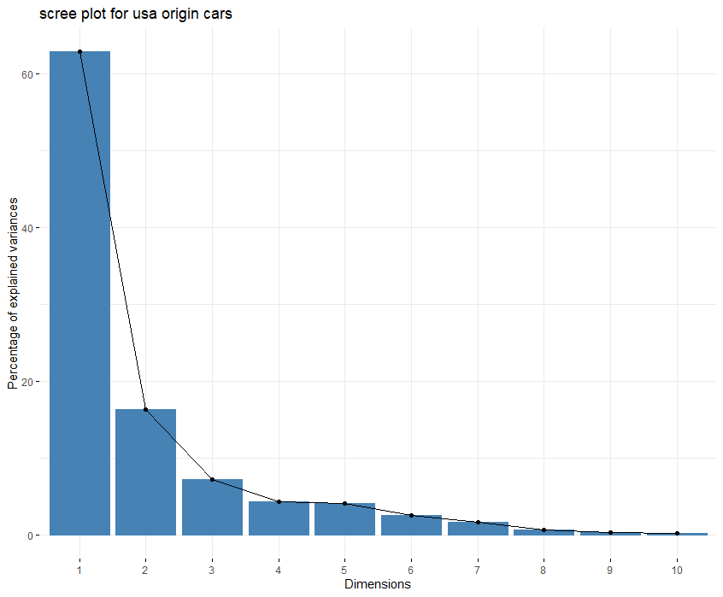
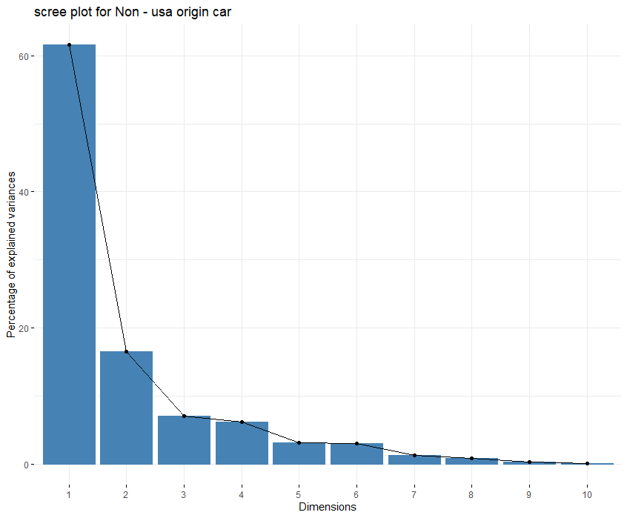
Scree plots for both the origin category US origin and Non-US origin car looks same and indicates that 2 Principal components have variance greater than 1 in both the cases and thus we will only consider 2 PCA.
Plotting using fviz_pca_ind library.
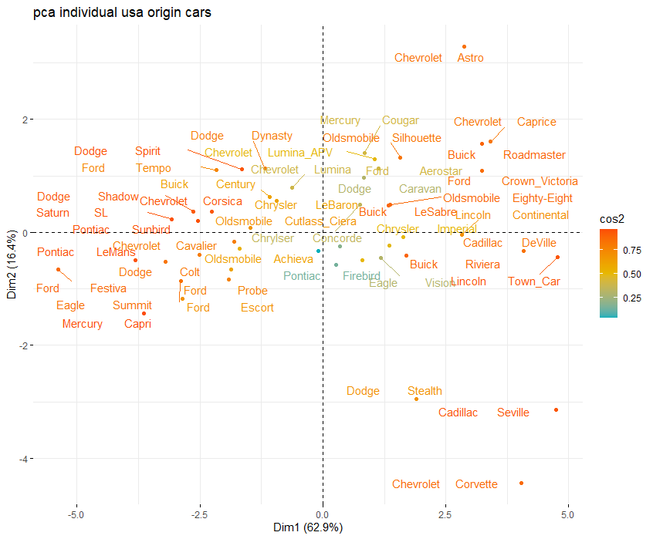
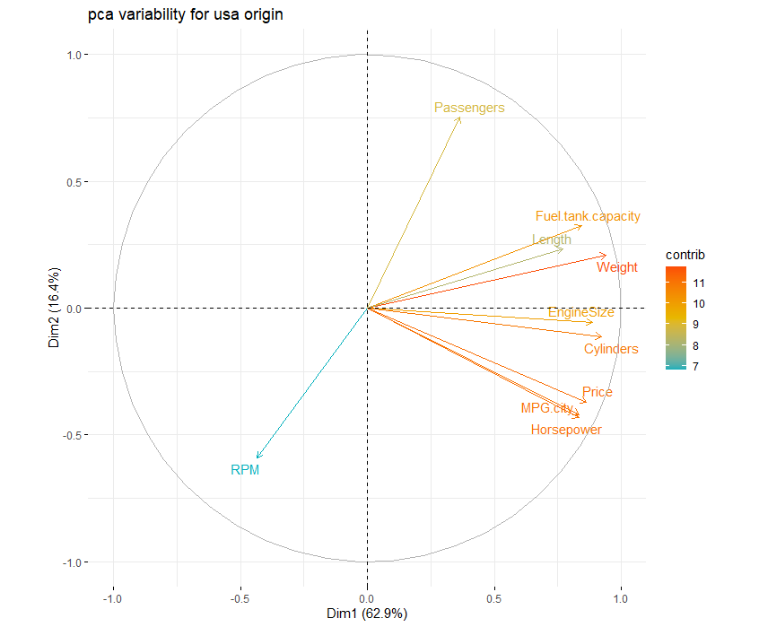
From the above two plots plotted for US origin cars. We see that PCA 1 extracts sufficient variance from variables Price, EngineSize, MPG.city, Cylinders, and Horsepower and these are more importance to PCA1. As these variables goes in X- axis direction.
And PCA 2 extracts sufficient variance from variables Fuel.tank.capacity, RPM, Weight, Passengers and Length. As these variable contribute in Y-axis direction
We can also identify which cars are similar in terms of the available features by looking at the plot, Like Chevrolet and astro are near by each other at top right and Chevrolet, corvette, stealth, cardilac, Seville and dodge are some what similar and lies near to each other in the plane.
Below are the plots for Non-US origin cars.

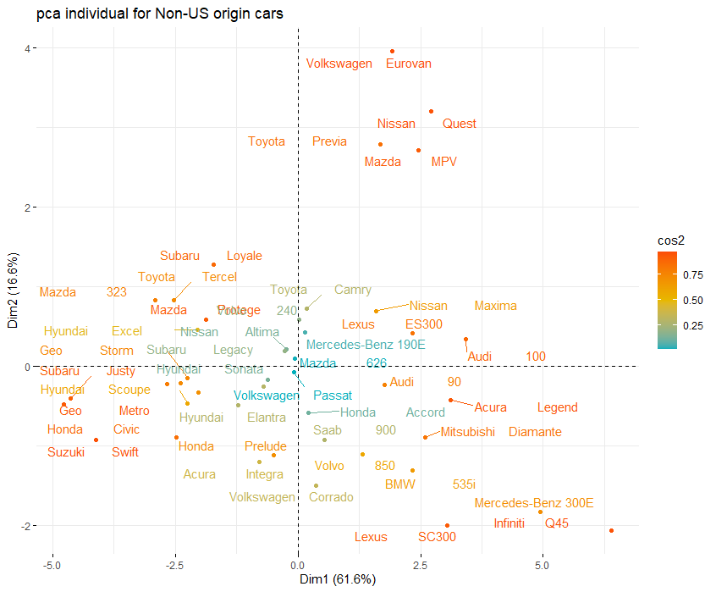
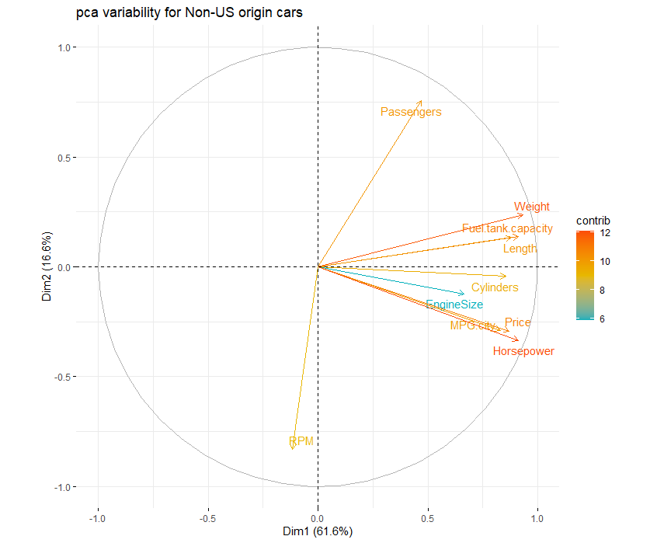

From the above two plots plotted for Non-US origin cars. We see that PCA 1 extracts sufficient variance from variables Price, EngineSize, MPG.city, Cylinders, and Horsepower and these are more importance to PCA1. As these variables goes in X- axis direction.
And PCA 2 extracts sufficient variance from variables Fuel.tank.capacity, RPM, Weight, Passengers and Length. As these variable contribute in Y-axis direction
We can also identify which cars are similar in terms of the available features by looking at the plot, Like Volkswagen, Eurovan, Nissan, Quest, mazda and mvp are near each other in the plane and we can say that these are the cars for someone who need high passenger, low rpm and low weight cars.

Factor Analysis
Factor analysis on the dataset using the “factanal” from the library “psych”.
Output:
Using factanal() function
Call:
factanal(x = cars.df, factors = 2, rotation = "varimax")

Uniquenesses:
Price EngineSize Fuel.tank.capacity RPM Weight MPG.city Cylinders
0.005 0.494 0.174 0.684 0.026 0.028 0.314
Horsepower Passengers Length
0.274 0.550 0.327

Loadings:
Factor1 Factor2
Price 0.992 0.102
EngineSize 0.446 0.555
Fuel.tank.capacity 0.545 0.727
RPM -0.562
Weight 0.582 0.797
MPG.city 0.985
Cylinders 0.604 0.567
Horsepower 0.748 0.408
Passengers 0.670
Length 0.456 0.682

Factor1 Factor2
SS loadings 3.924 3.202
Proportion Var 0.392 0.320
Cumulative Var 0.392 0.713

Test of the hypothesis that 2 factors are sufficient.
The chi square statistic is 168.29 on 26 degrees of freedom.
The p-value is 8.74e-23

Use “fa” command from library “FactoMineR”
Factor Analysis using method = pa
Call: factor.pa(r = cars.df, nfactors = 2, rotate = "varimax")
Unstandardized loadings (pattern matrix) based upon covariance matrix
PA1 PA2 h2 u2 H2 U2
Price 0.95 -0.06 0.91 0.09 0.91 0.09
EngineSize 0.54 -0.54 0.59 0.41 0.59 0.41
Fuel.tank.capacity 0.60 -0.64 0.77 0.23 0.77 0.23
RPM 0.04 0.66 0.44 0.56 0.44 0.56
Weight 0.65 -0.73 0.95 0.05 0.95 0.05
MPG.city 0.91 -0.01 0.83 0.17 0.83 0.17
Cylinders 0.68 -0.54 0.76 0.24 0.76 0.24
Horsepower 0.89 -0.22 0.84 0.16 0.84 0.16
Passengers 0.03 -0.67 0.45 0.55 0.45 0.55
Length 0.49 -0.68 0.70 0.30 0.70 0.30

PA1 PA2
SS loadings 4.32 2.92
Proportion Var 0.43 0.29
Cumulative Var 0.43 0.72
Proportion Explained 0.60 0.40
Cumulative Proportion 0.60 1.00

Standardized loadings (pattern matrix)
item PA1 PA2 h2 u2
Price 1 0.95 -0.06 0.91 0.09
EngineSize 2 0.54 -0.54 0.59 0.41
Fuel.tank.capacity 3 0.60 -0.64 0.77 0.23
RPM 4 0.04 0.66 0.44 0.56
Weight 5 0.65 -0.73 0.95 0.05
MPG.city 6 0.91 -0.01 0.83 0.17
Cylinders 7 0.68 -0.54 0.76 0.24
Horsepower 8 0.89 -0.22 0.84 0.16
Passengers 9 0.03 -0.67 0.45 0.55
Length 10 0.49 -0.68 0.70 0.30

PA1 PA2
SS loadings 4.32 2.92
Proportion Var 0.43 0.29
Cumulative Var 0.43 0.72
Cum. factor Var 0.60 1.00

Mean item complexity = 1.5
Test of the hypothesis that 2 factors are sufficient.

The degrees of freedom for the null model are 45 and the objective function was 12.68 with Chi Square of 1101.15
The degrees of freedom for the model are 26 and the objective function was 3.32

The root mean square of the residuals (RMSR) is 0.06
The df corrected root mean square of the residuals is 0.07

The harmonic number of observations is 92 with the empirical chi square 25.52 with prob < 0.49
The total number of observations was 92 with Likelihood Chi Square = 284.18 with prob < 3e-45

Tucker Lewis Index of factoring reliability = 0.57
RMSEA index = 0.328 and the 90 % confidence intervals are 0.296 0.366
BIC = 166.61
Fit based upon off diagonal values = 0.99
Measures of factor score adequacy
PA1 PA2
Correlation of (regression) scores with factors 0.99 1
Multiple R square of scores with factors 0.99 1
Minimum correlation of possible factor scores 0.98 1

In the above I have selected 2 factors and performed factor analysis on it and based on the p value and test of the hypothesis evaluation we found that 2 factors are sufficient. We can identify the commonality and uniqueness too from the output as well as loading based upon covariance matrix and Standardized loadings too.
This output aligns with what we got in PCA and thus 2 factors are sufficient.
Next Using “fa” command from library “FactoMineR” and compare the result with previous one.
Single factor parallel
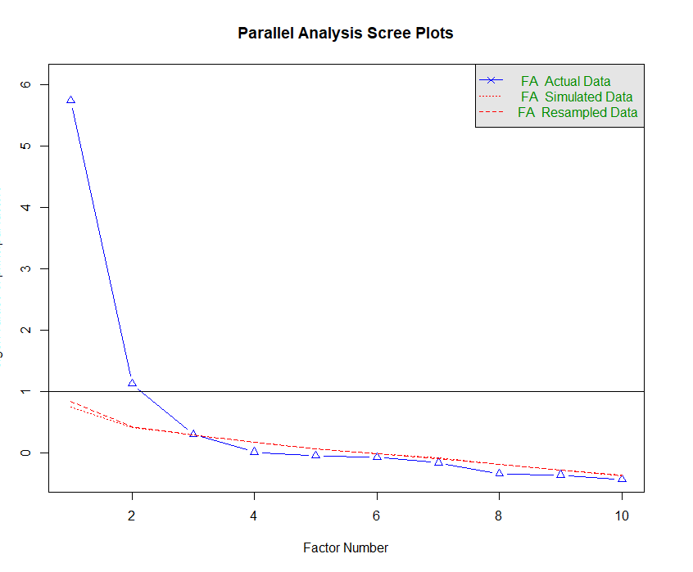
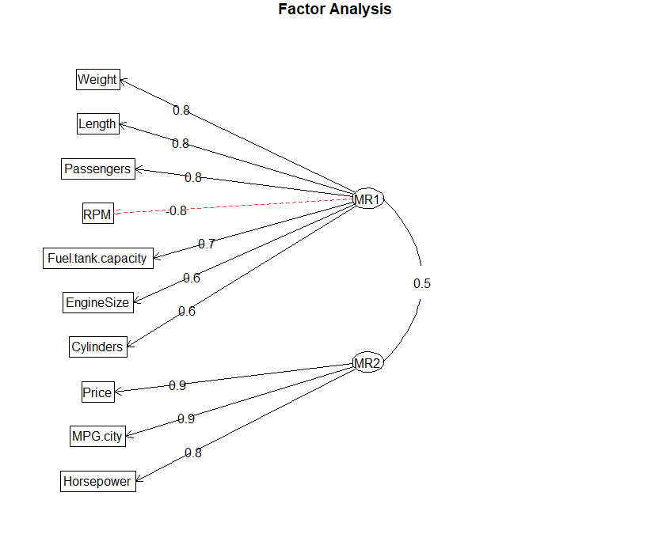
Above Fa parallel plot also confirms 2 factor having variance greater than 1 and thus can be retained. While in second plot we see which variables can be merged in which factors.
So,
MR1 (factor 1) = 0.8* weight + 0.8* Length + 0.8 * passenger + 0.8* RPM + 0.7 Fuel.Tank.Capacity + 0.6 * Engine Size + 0.6 * Cylinder
MR2 (factor 2) = 0.9 * price + 0.9 * MPG.City + 0.8 * horsepower
Now using nFactors as 3 we get:
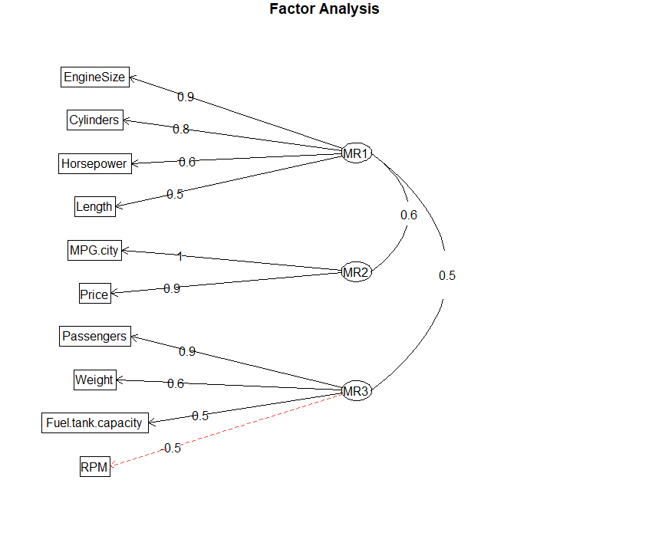
MR1 (factor 1) = 0.5* Length + 0.9 * Engine Size + 0.8 * Cylinder + 0.6 * horsepower
MR2 (factor 2) = 0.9 * price + 1 * MPG.City + 0.8 * horsepower
MR3 (factor 3) = 0.9 * passenger + 0.6 * weight + 0.5 * Fuel.Tank.Capacity + 0.5* RPM
Clearly we get different outputs for different number of factors.

final PCA model for this dataset
Next we Split the dataset into two groups by its origin (USA-cars and NonUSA-cars). Using the “split” command in R and repeated the PCA and FA analyses on one of these two datasets. I performed on USA-cars.

PCA and FA analysis for only for USA-cars

Below is the summary output of PCA analysis of USA - cars

Importance of components:
PC1 PC2 PC3 PC4 PC5 PC6 PC7 PC8 PC9 PC10
Standard deviation 2.5081 1.2789 0.84630 0.65741 0.63487 0.50019 0.39808 0.26092 0.17649 0.12034
Proportion of Variance 0.6291 0.1636 0.07162 0.04322 0.04031 0.02502 0.01585 0.00681 0.00311 0.00145
Cumulative Proportion 0.6291 0.7926 0.86424 0.90746 0.94776 0.97278 0.98863 0.99544 0.99855 1.00000

We obtained 10 principal components, which is names as PC1-PC10. Each of these explains a percentage of the total variation in the dataset. That is to say: PC1 explains 62.9% of the total variance, which means that nearly two-thirds of the information in the dataset can be explained by just that one Principal Component. PC2 explains 16.36% of the variance and so on. So, by knowing the position of a sample in relation to just PC1 and PC2, we can get a very accurate view on where it stands in relation to other samples, as just PC1 and PC2 can explain 79.26% of the variance.
The cumulative proportion in the above table is nothing but the sum of adjacent PCA, adding to 1 at last.
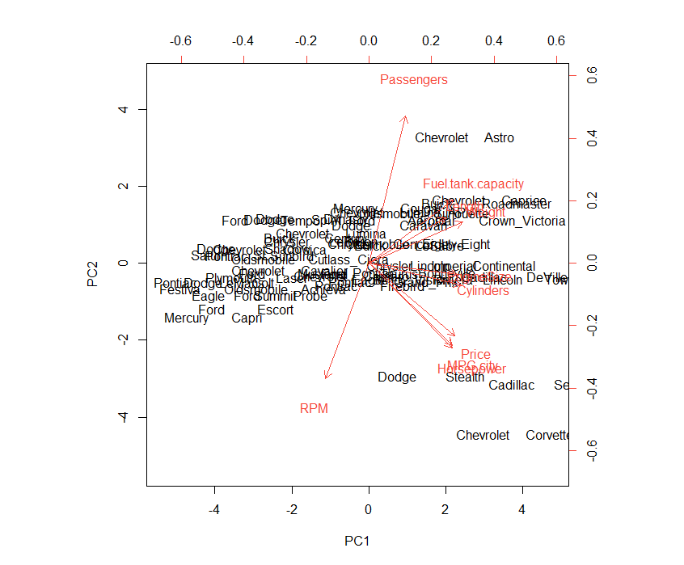
From the above plot we get idea on realtion between car and feature for PC1 and PC2. Stealth, cardillac, Chevrolet, corvette have high price, high MPG and high horsepower, similarly Chevrolet and astro have more passenger space and fuel capacity.

Loading data:
We can identify loading for variable for each PC from above.

Eigen values:
PC1 | PC2 | PC3 | PC4 | PC5 | PC6 | PC7 | PC8 | PC9 | PC10
6.29058617 | 1.63557415 | 0.71622236 | 0.43218353 | 0.40306285 | 0.25019275 | 0.15846639 | 0.06808118 | 0.03114999 | 0.01448063

Factor analysis for usa origin cars
Now after PCA performing Factor analysis.
Output for factanal() is shown below:

Call:
factanal(x = usa_data, factors = 2, rotation = "varimax")

Uniquenesses:
Price EngineSize Fuel.tank.capacity RPM Weight MPG.city Cylinders
0.021 0.339 0.178 0.718 0.017 0.024 0.215
Horsepower Passengers Length
0.277 0.530 0.419

Loadings:
Factor1 Factor2
Price 0.982 0.122
EngineSize 0.677 0.450
Fuel.tank.capacity 0.473 0.774
RPM -0.134 -0.514
Weight 0.630 0.765
MPG.city 0.984
Cylinders 0.753 0.467
Horsepower 0.793 0.306
Passengers 0.686
Length 0.487 0.586

Factor1 Factor2
SS loadings 4.463 2.799
Proportion Var 0.446 0.280
Cumulative Var 0.446 0.726

Test of the hypothesis that 2 factors are sufficient.
The chi square statistic is 96.99 on 26 degrees of freedom.
The p-value is 4.05e-10

Above output also suggests that 2 factors are sufficient for FA. Now using factor.pa()

Factor Analysis using method = pa
Call: factor.pa(r = usa_data, nfactors = 2, rotate = "varimax")
Unstandardized loadings (pattern matrix) based upon covariance matrix
PA1 PA2 h2 u2 H2 U2
Price 0.93 -0.15 0.88 0.12 0.88 0.12
EngineSize 0.74 -0.44 0.75 0.25 0.75 0.25
Fuel.tank.capacity 0.51 -0.75 0.82 0.18 0.82 0.18
RPM -0.11 0.56 0.33 0.67 0.33 0.67
Weight 0.66 -0.74 0.98 0.02 0.98 0.02
MPG.city 0.93 -0.09 0.87 0.13 0.87 0.13
Cylinders 0.82 -0.41 0.84 0.16 0.84 0.16
Horsepower 0.91 -0.11 0.83 0.17 0.83 0.17
Passengers -0.04 -0.70 0.50 0.50 0.50 0.50
Length 0.50 -0.58 0.58 0.42 0.58 0.42

PA1 PA2
SS loadings 4.73 2.65
Proportion Var 0.47 0.26
Cumulative Var 0.47 0.74
Proportion Explained 0.64 0.36
Cumulative Proportion 0.64 1.00

Standardized loadings (pattern matrix)
item PA1 PA2 h2 u2
Price 1 0.93 -0.15 0.88 0.12
EngineSize 2 0.74 -0.44 0.75 0.25
Fuel.tank.capacity 3 0.51 -0.75 0.82 0.18
RPM 4 -0.11 0.56 0.33 0.67
Weight 5 0.66 -0.74 0.98 0.02
MPG.city 6 0.93 -0.09 0.87 0.13
Cylinders 7 0.82 -0.41 0.84 0.16
Horsepower 8 0.90 -0.11 0.83 0.17
Passengers 9 -0.04 -0.70 0.50 0.50
Length 10 0.50 -0.57 0.58 0.42

PA1 PA2
SS loadings 4.73 2.65
Proportion Var 0.47 0.27
Cumulative Var 0.47 0.74
Cum. factor Var 0.64 1.00

Mean item complexity = 1.4
Test of the hypothesis that 2 factors are sufficient.

The degrees of freedom for the null model are 45 and the objective function was 13.37 with Chi Square of 572.64
The degrees of freedom for the model are 26 and the objective function was 3.23

The root mean square of the residuals (RMSR) is 0.04
The df corrected root mean square of the residuals is 0.06

The harmonic number of observations is 48 with the empirical chi square 8.48 with prob < 1
The total number of observations was 48 with Likelihood Chi Square = 133.87 with prob < 1.7e-16

Tucker Lewis Index of factoring reliability = 0.634
RMSEA index = 0.293 and the 90 % confidence intervals are 0.248 0.348
BIC = 33.22
Fit based upon off diagonal values = 0.99

This result also aligns with our all the previous analysis and confirms that 2 factors are sufficient.

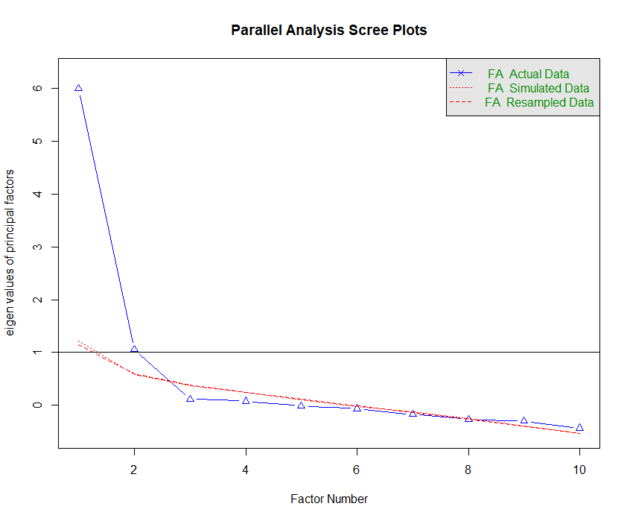
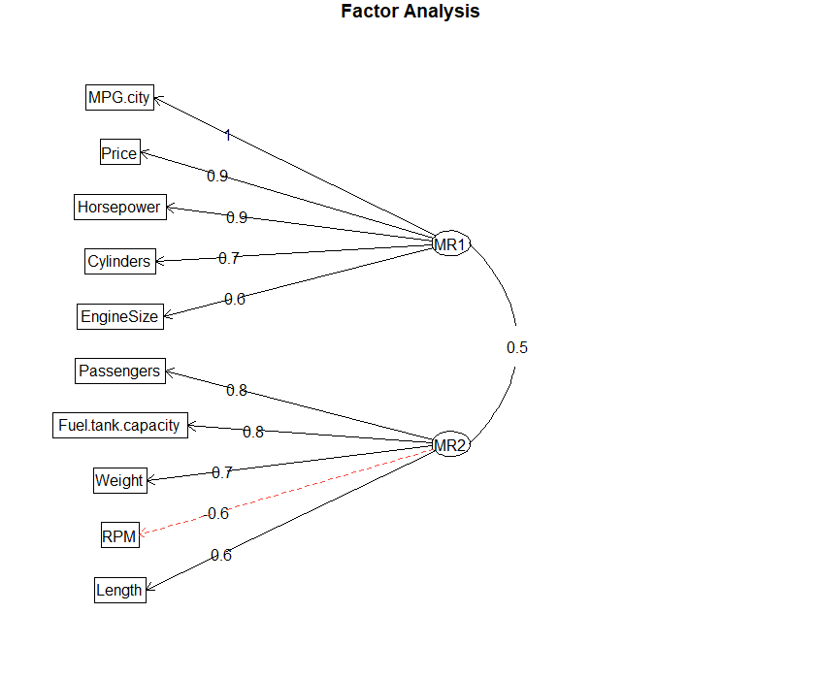
From the parallel analysis it is clear that 2 factor have variance greater than 1 and thus can be retained.
MR1 (factor 1) = 1 * MPG.City + 0.9 * price + 0.9 * horsepower + 0.7 * Cylinder+ 0.6 * Engine Size MR2 (factor 2) = 0.8 * passenger + 0.8* Fuel.Tank.Capacity + 0.7 * weight + 0.6* RPM+ 0.5* Length
But the factors look different from the previous one.

Comparing
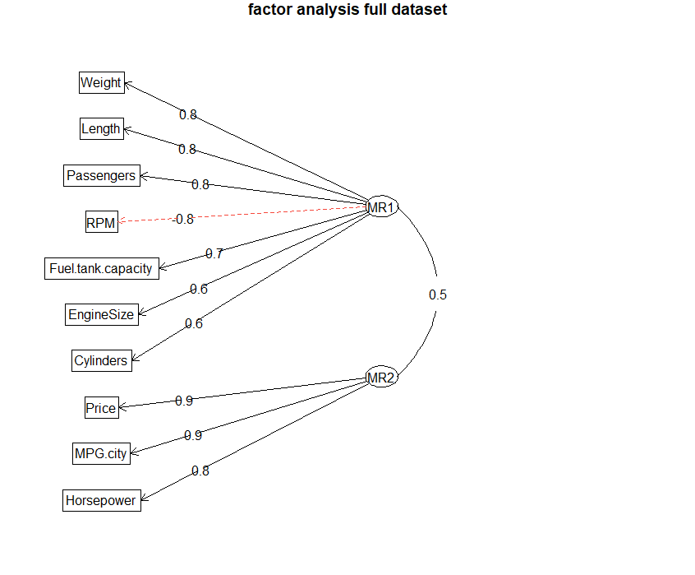
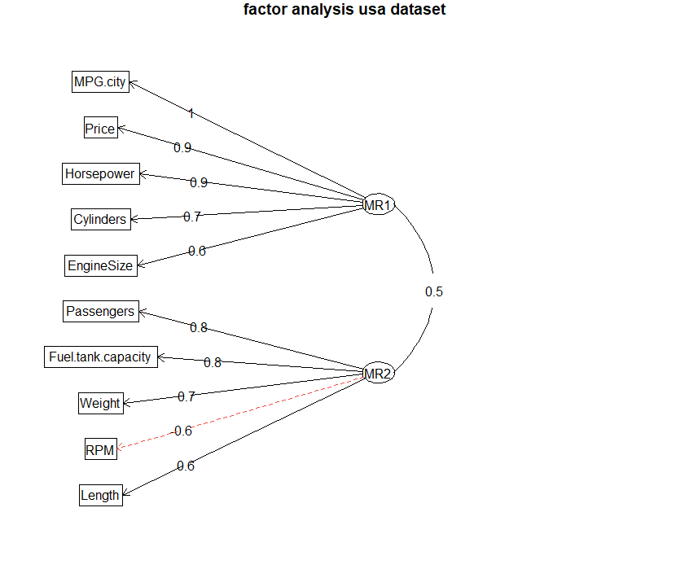
Comparing both the Plots with original dataset and the other with only cars origin USA. We see that the factors are different in both plots. While factor 1 in full dataset has 7 features in it and factor 2 has 3 whereas, plot for usa dataset has equally distributed features in both the factors i.e. 5.
References
[1] “A Guide to Bartlett’s Test of Sphericity,” Statology, Apr. 23, 2019. https://www.statology.org/bartletts-test-of-sphericity/ (accessed May 20, 2022).
[2] “Factor Analysis,” May 05, 2017. https://www.geo.fu-berlin.de/en/v/soga/Geodata-analysis/factor-analysis/index.html (accessed May 20, 2022).
[3] “Getting Started with Factor Analysis | University of Virginia Library Research Data Services + Sciences.” https://data.library.virginia.edu/getting-started-with-factor-analysis/ (accessed May 22, 2022).

